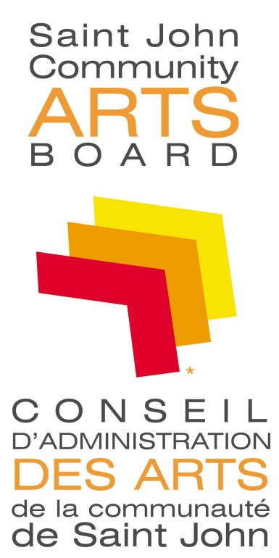**PROGRAM GUIDE**

**1. Rationale**

As described in the City of Saint John *Arts and Culture Policy,* adopted by Common Council on September 26, 2005, the arts make a substantial contribution to the quality of life and vitality of our community. The City of Saint John believes that one of the most effective means of facilitating the development of arts and culture in Saint John is to provide funding support to non-profit arts and/or cultural organizations serving our community. In this way, arts and culture organizations are encouraged to establish themselves, enhance their services, and provide their programming to the community. Accordingly, the City through the Saint John Community Arts Board has implemented the ***Community Arts Funding Program***. This Program is designed to provide project support for non-profit organizations or groups wishing to offer quality arts activities in any discipline of the creative arts within the City of Saint John.

**2. Community Arts Funding Program**

The *Community Arts Funding Program* is administered by the Saint John Community Arts Board on behalf of the City of Saint John. The Program provides financial support in two categories:

* **Project/Activity Funding** - Arts-related projects, activities, events or initiatives (including a series of activities or events) that are primarily participatory, actively engage the public, are educational in nature, or that develop the arts in the community.
* **Arts Festival Funding** – Preparation and presentation of one-day or multi-day arts festivals, major arts events, or arts celebrations.

Program grants will normally range between $500 and $3,000 (or between 10% and 40% of your total project/festival budget).

**3. Eligible Organizations**

Any non-profit organization whose primary purpose is the presentation, promotion, or education of the visual, performing, literary, media, or material arts in Saint John, and that wishes to undertake arts-related projects or activities of benefit to the community, is eligible to apply. An organization that has previously received Program funding and that has not complied with funding requirements (e.g.: failed to submit a post-event report to the Board) will be deemed ineligible.

**4. Restrictions**

The following are examples of applicants and/or projects/activities that are not eligible for funding:

* Building or equipment purchase, lease, renovation or repair;
* Funding that is primarily for the benefit of an individual;
* For-profit organizations;
* Organizations that fund other projects/festivals;
* Retroactive funding (without prior approval of the Board);
* Deficits or debts;
* Free or discounted tickets;
* Fundraising events;
* Fellowships, scholarships, or bursaries;
* Contributions to an endowment fund;
* Conferences or professional development; and
* Non-specific operating expenses.

**5. Criteria for Evaluation**

During evaluation of applications, preference will be given to organizations that are based in Saint John and to projects and/or activities:

* that are consistent with the objectives of the City’s Arts and Culture Policy;
* that are consistent with the priorities of Saint John City Council;
* with significant community involvement;
* with significant community involvement in priority neighbourhoods;
* that have not received other material funding from the City of Saint John and have not received funding under this Program within the last 12 months;
* that have also sought and/or obtained other sources of funding (e.g. matching funds); and
* that will benefit the creative arts, the arts community and the community at large.

The applicant must also demonstrate organizational capacity and good management practices, including programming, finances, and human resources. Other practices will also be taken into account - such as: event attendance; audience development; community and business support; cultural diversity; funding; human resources; partnerships; public accessibility; and strategic planning.

**6. Evaluation Process**

The Saint John Community Arts Board will review and evaluate each application using this Program Guide and any other applicable program criteria as a framework for discussion. The Board will then determine which projects and/or activities will receive funding and the level of funding to be awarded based on the approved applications and the availability of funds.

The amount of funding available is determined annually by Common Council. Applicants will normally be notified of the adjudication results by writing within 45 days after the application deadline.

Saint John Community Arts Board members who are also members of an applying organization will not be entitled to participate in the evaluation and decision process relating to that organization’s request for funding.

**7. How to Apply**

PDF versions of the City’s Arts and Culture Policy are available on the City of Saint John web site at [***www.saintjohn.ca***](http://www.saintjohn.ca)

Applications must be clear, concise and complete. Incomplete or inaccurate applications will be rejected. Two members of the Executive or Board of the applicant organization must sign the original application. Completed applications and all supporting documents must be sent to:

By E-Mail: Cultural Affairs Office

culturalaffairs@saintjohn.ca

By Hand-Delivery: Community Arts Funding Program

c/o Cultural Affairs Office

City of Saint John

8th floor, City Hall

15 Market Square

Saint John, NB

Please include the name of the applying organization in the subject line and name all attachments appropriately.

**8. Application Closing Date**

Applications must be received or postmarked no later than  
4:00 pm on Thursday, May 4, 2017.

**9. Further Information**

For further information or assistance, please contact:

Cultural Affairs Office, City of Saint John

(506) 649-6040

E-mail: ***culturalaffairs@saintjohn.ca***

City of Saint John web site: [***www.saintjohn.ca***](http://www.saintjohn.ca)